

**Coursework Title:**

**Course: COMP1640 Enterprise Web Software Development**

**Due date: 12th April 2018**

**Student Name: Nguyen Ngoc Chan**

**Student ID: GT60826**

|  |  |  |
| --- | --- | --- |
| **COLLECTING IDEAS MANAGEMENT SYSTEM** | | |
| **Group members** | Nguyen Ngoc Chan | Scrum Master, Tester |
| Hoang Ngan Giang | Developer, DB |
| Tran Hoang Long | Developer, DB |
| Trieu Phu Vinh | Developer, Tester |
| Doan Dinh Huy | Developer, Designer |
| **Teacher** | To Hoai Viet | |

URL for the Screencast:

<https://drive.google.com/open?id=1hhG8IakT5zDHJVasPwQt3jYs7vycI5ui>

URL for the source code:

<https://github.com/kenguyen01/blogapplication>

URL for group document:

<https://drive.google.com/file/d/1X9XebNf6t1i_btyqbmw6_BX_yf63T5N-/view?usp=sharing>

1. **Introduction**

This is a report about the developing of web application, product, self - evaluation and team working evaluation. Based on the requirements of coursework, we create a web application which can perform features such as collecting ideas from users, users can also add comment on each idea, thumb up when they like it and thumb down when they dislike it. The development methodology we use in this project is SCRUM methodology.

SCRUM is a software development method that shows how the team works effectively to create a software product. The main principle is to split the software to produce a small part to develop (these parts have to read and release), get customer comments and change accordingly during the feedbacks. This will ensure that the release product meets what the customer expects.

SCRUM is based on the nature of the developer so it is easy to understand, easy to apply, creates high interactivity among programmers in the team and creates good products together. Instead of being imposed from the outside.

|  |  |  |  |
| --- | --- | --- | --- |
| Role | Username | Password | Department |
| Admin | admin | 123 |  |
| QA manager | manager | 123 |  |
| QA coordinator | coordinator1 | 123 | Software Engineering |
| QA coordinator | coordinator2 | 123 | Finance |
| QA coordinator | coordinator3 | 123 | Banking |
| QA coordinator | coordinator4 | 123 | Foreign Language |
| Student | student1 | 123 | Software Engineering |
| Student | student2 | 123 | Finance |
| Student | student3 | 123 | Banking |
| Student | student4 | 123 | Foreign Language |

1. **Evaluation**

Working together, out team has created a web application which performs fully features in the requirements. I can evaluate the product as below:

* Template: 95%
* Functions: 90%
* Perform: 95%
* In time: 100%

The evidence is shown below:

1. 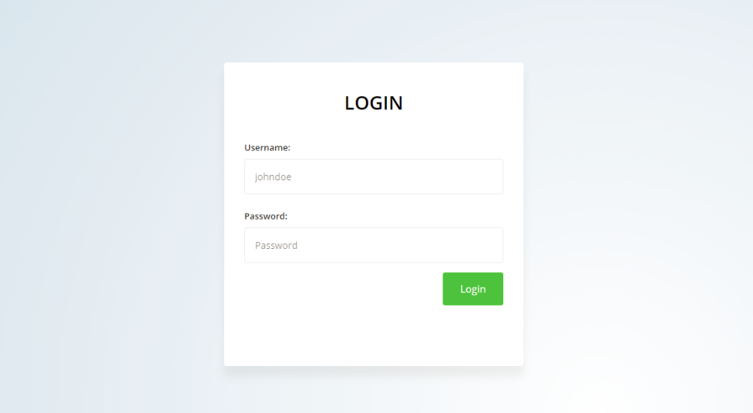**Product**

**Login Page**

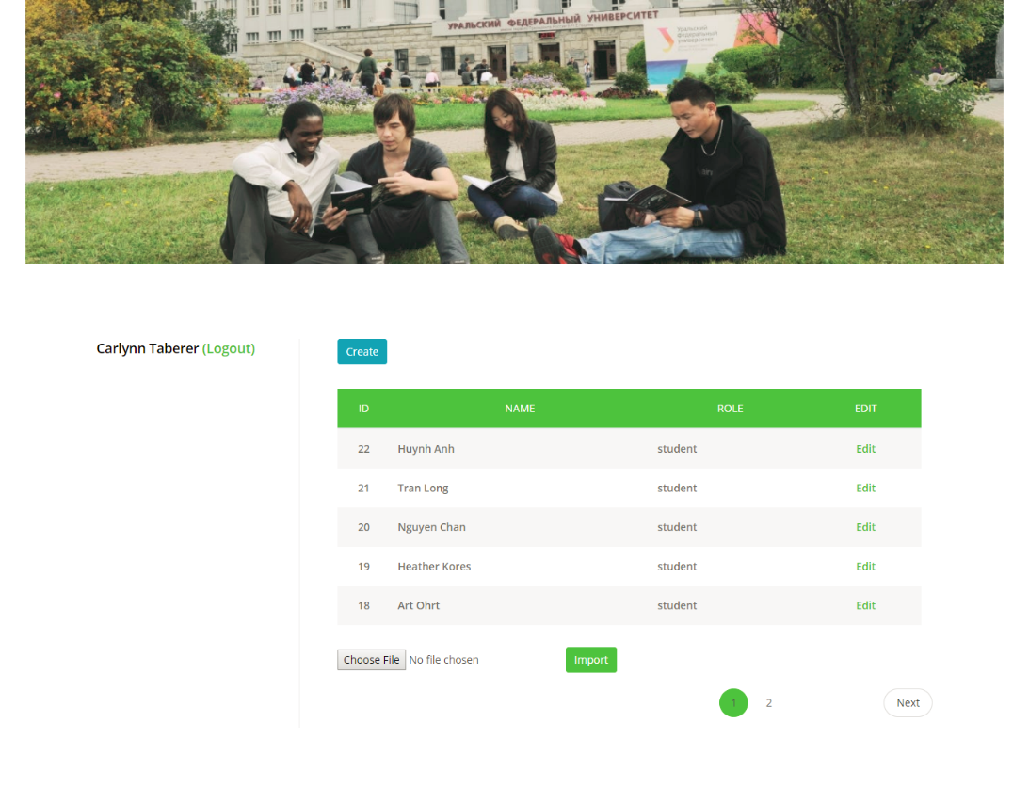

**Admin Home Page**

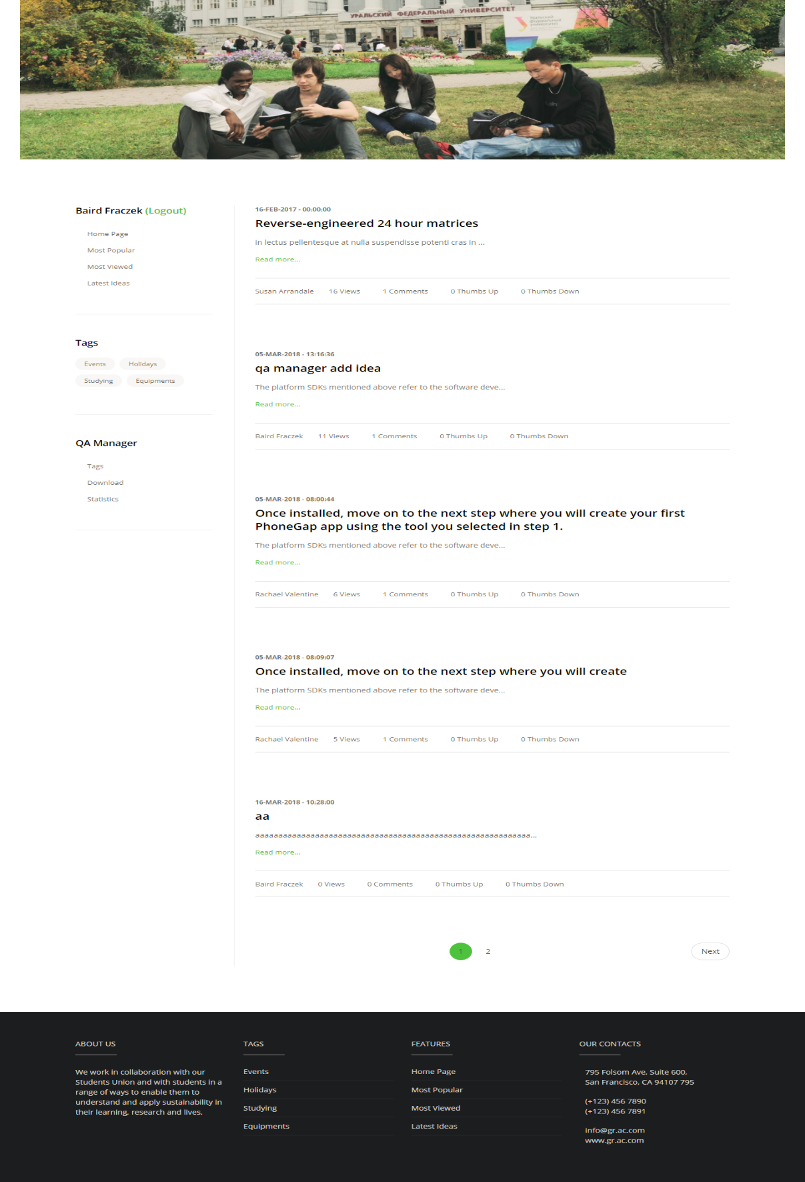

**QA Manager Home Page**

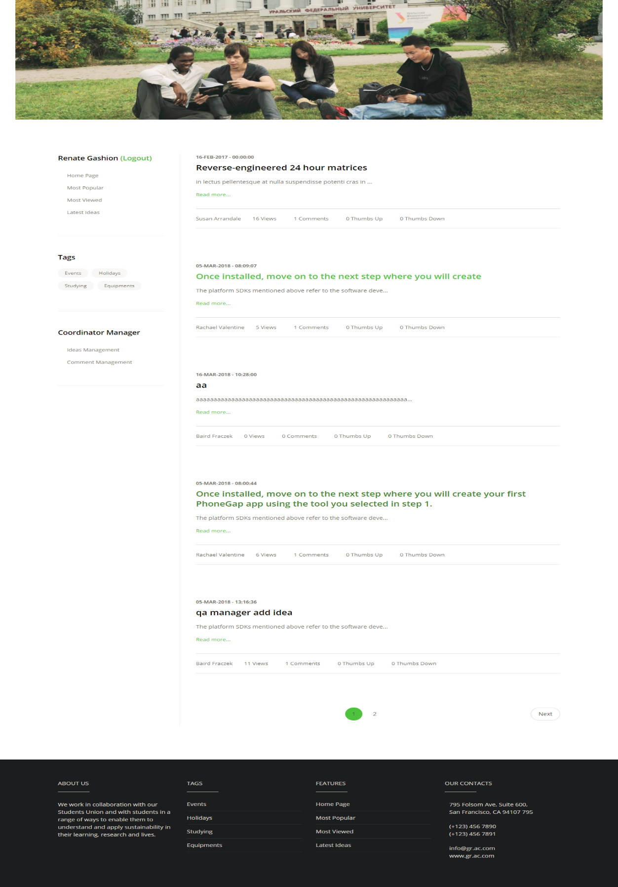

**QA Coordinator Manager Home Page**

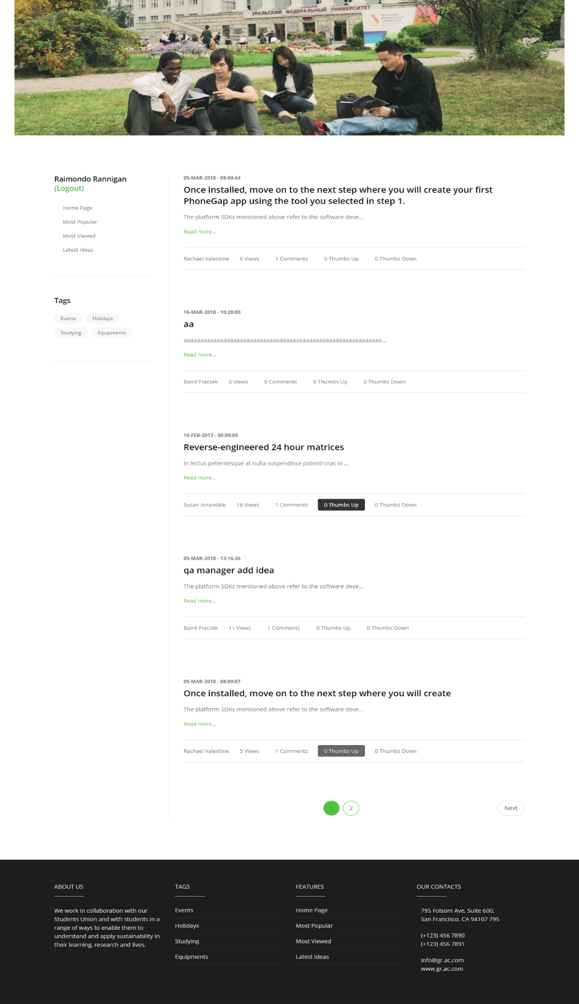**Student Home Page**

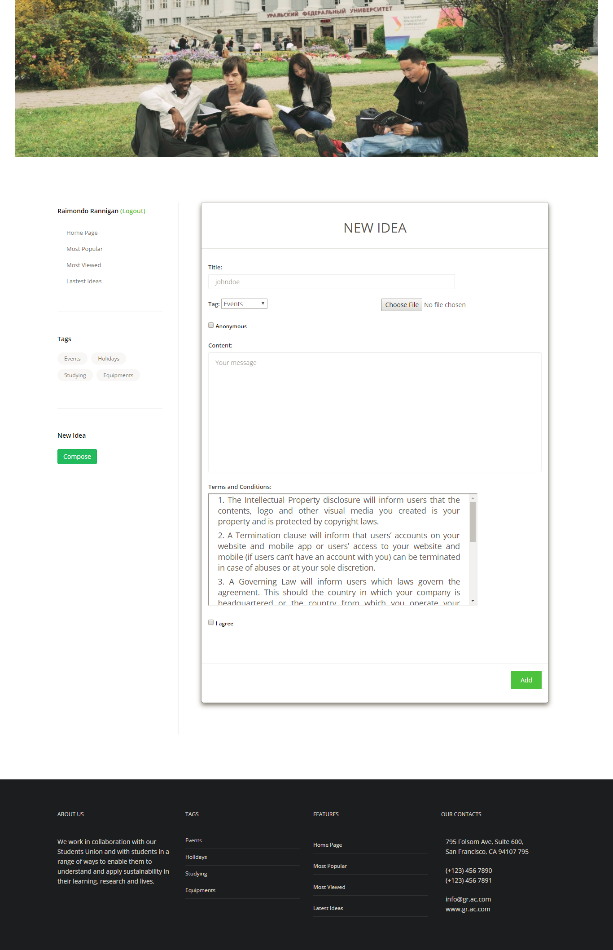**Add New Idea Page**

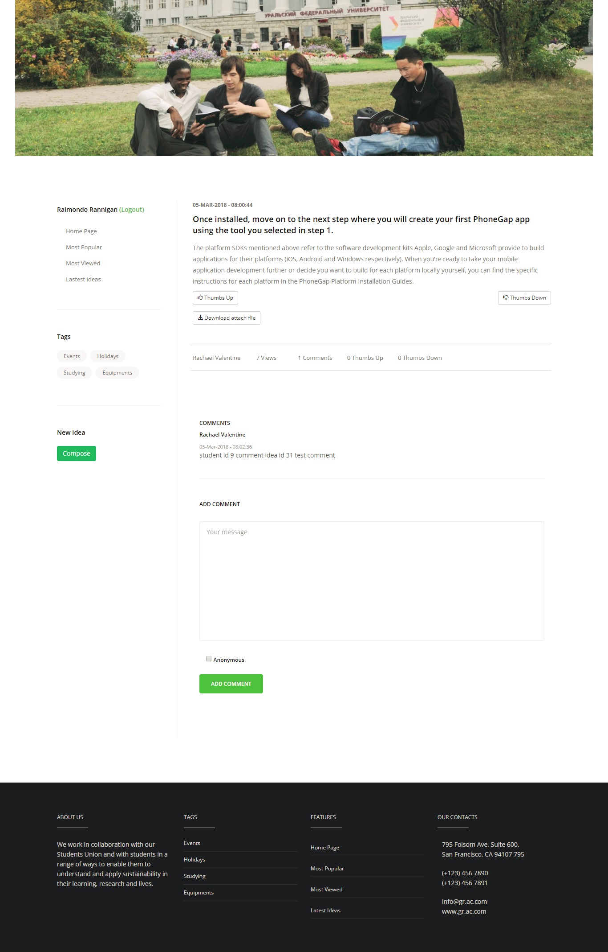**Add Comment Page**

* **Full features implementing**

Our group has develop a web role based application which performs features as required. Four roles have been built in the system:

1. Admin

* Maintain system.
* Add, edit staff members.
* Add, edit students.
* Import staff members, students from excel file.
* Login, logout.

1. QA Manager

* Add idea.
* Add comment.
* Add, edit, and remove tags.
* Statistic report.
* Download files.
* View ideas and comments.
* Thumb up, thumb down idea.
* Login, logout.

1. QA Coordinator

* Add idea.
* Add comment.
* Manage ideas, comments.
* Thumb up, thumb down idea
* View ideas and comments.
* Login, logout.

1. Student

* Add idea.
* Add comment.
* View ideas and comments.
* Thumb up, thumb down idea.
* Login, logout.
* **Easy to use**

The application is designed for users easy to use, it is also available on many devices such as PC, tablets, cellphones. Navigations on the application is design logically for users to interact with. Buttons are also designed with distinguish style, they are large enough for users’ clickable. Text style and text size are used properly, headers are larger than other text, and users can easily obtain the information. Background color is chosen properly, it’s suitable with the layout.

1. **Process**

*Sprint backlog (2.5 Group Document)*

According to works that have been set up in sprint backlog, to complete each sprint in time, I have to arrange works properly in order to finish task in time.

*Product backlog (2.4 Group Document)*

In this phase, I have to determine which is important, and which is less important, what to be done first, after that, I have to finish them on time.

*Meeting (2.3 Group Document)*

To finish my task, I have to attend all group meetings in order to check other members’ working, give them right criteria for their task and also check my working, to be sure that my work is on the right way.

1. **Team**

**Hoang Ngan Giang**

He is a good programmer, he takes important works. He has finished tasks on time, and his task works properly without any errors. Moreover, he has a strong knowledge in programming, he is willing to help other members whenever they have trouble.

**Tran Hoang Long**

He works with a high sense of responsibility, he always tries to finish his task on time. He always joins group meetings and frequently reports his work to team leader. In addition, he is a good listener, he always accepts ideas from others and learning from them.

**Trieu Phu Vinh**

He is an active member of the team, always helps other members when they stuck with any task. He always present in all group meetings, suggests better ideas to finish the project properly. Besides that, he a good programmer, always finish his task before schedule and willing to take important tasks.

**Doan Dinh Huy**

He is a creative person, he always has a better solutions for the team. With his strong skill in programming, he is always finish the tasks on time. Moreover, he also suggests build more functions to make the project become better. He joins every group meetings, and helps the team so much.

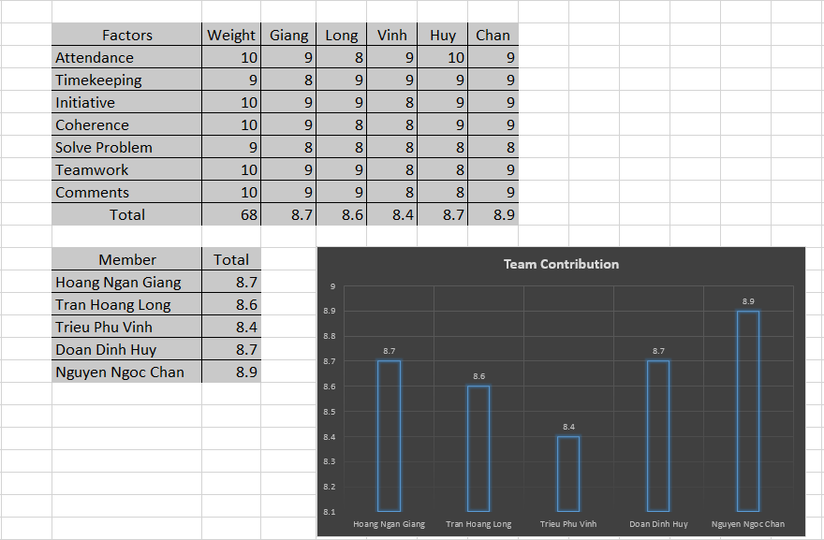

Figure 1

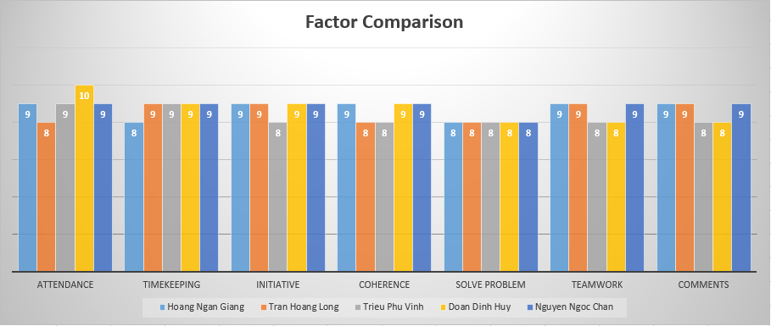

Figure 2

Based on the above score tables and charts, everyone in my team contributes positively to the whole project. Hoang Ngan Giang and Doan Dinh Huy have done a great job, they always suggest better solutions for the team, and always help other to overcome difficult tasks. On other hand, Tran Hoang Long and Trieu Phu Vinh also did a well contribution to the team, although they have some weak point, but they always try the best to finish tasks.

1. **Self – evaluation**

In the application, I build functions of admin role, and statistics reports of QA manager

* Add, edit staff members.
* Add, edit students.
* Import staff members, students from excel file.
* Set closure date.
* Statistics report.
* Design database.

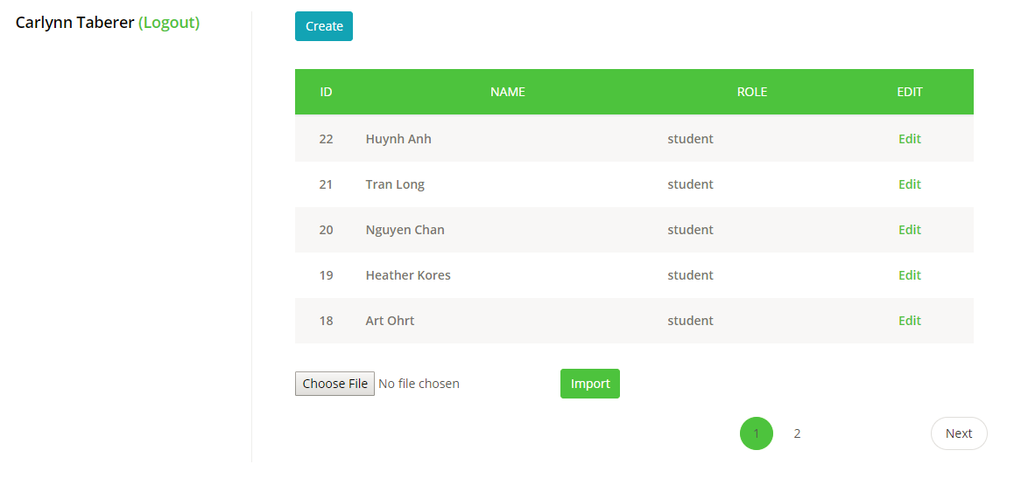

Admin Home Page

*Instead of add new user manually, I also add function import users from excel file

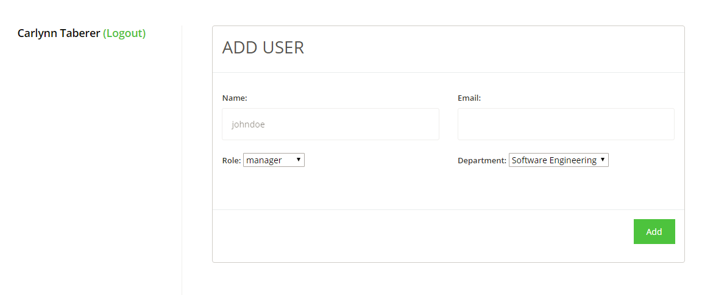

Add New User

*Username and Password are automatically generated for users by the system and then username and password will be sent to users via email.

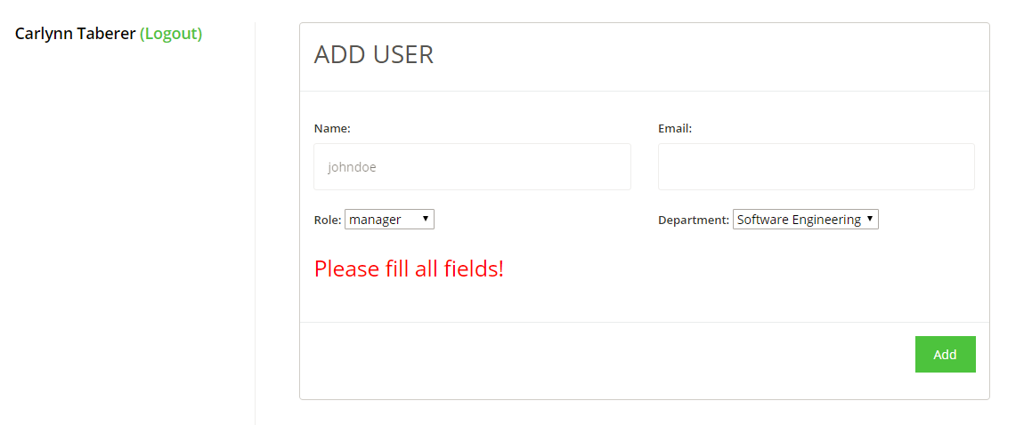

Validation

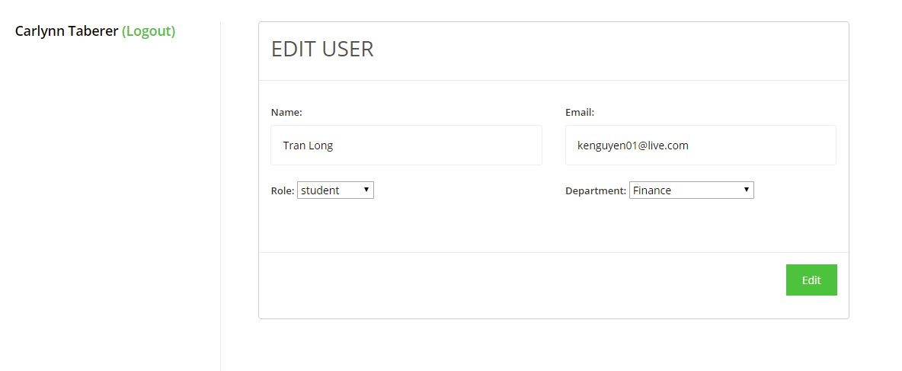

Edit User

* Set up closure date: In this application, I set up closure date is 2018 – 04 – 03, three days before closure date (2018 – 03 – 31) users can add new idea and post comment on any idea. Before 2018 – 04 – 03 users can only post comment and can’t add new idea. And finally, after 2018 – 04 – 03, users can not add new idea and post comment.

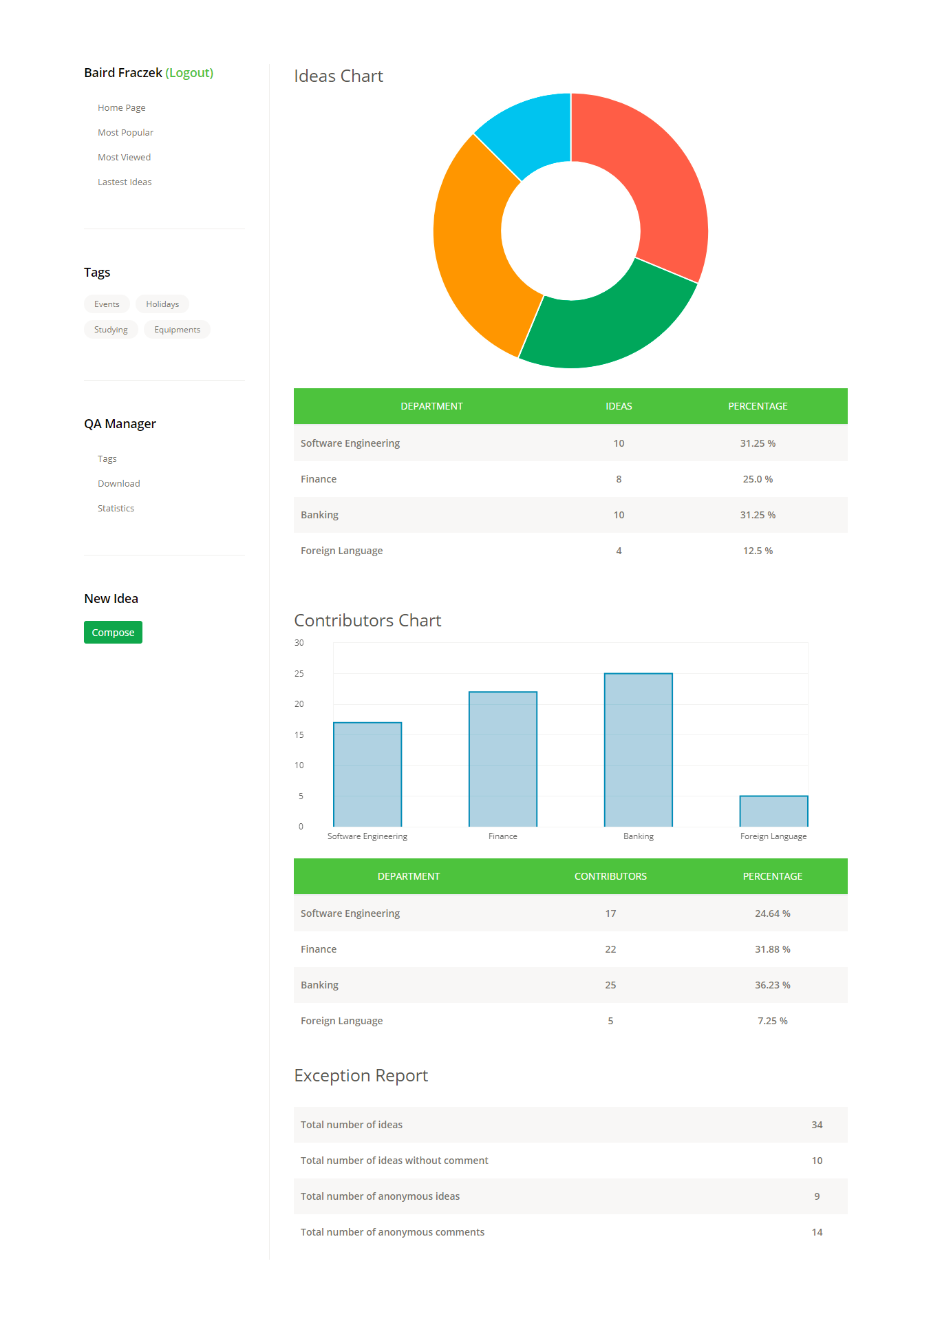

Statistic Report

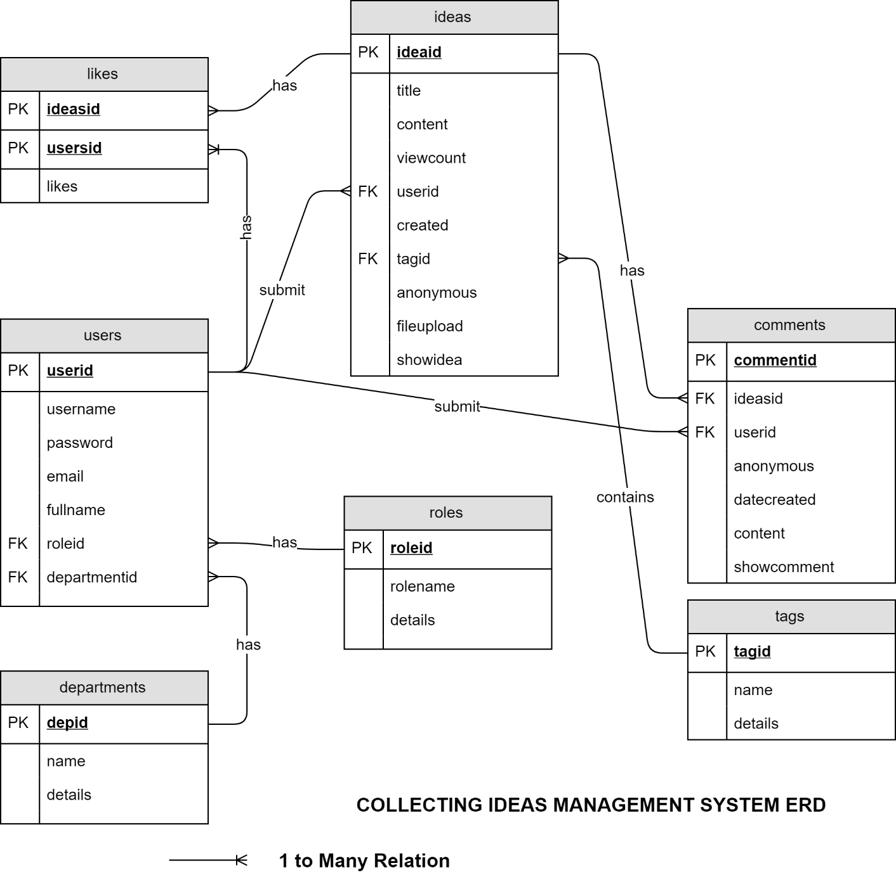

*Working*

As a SCRUM master of the group, I always give positive attitude in helping other member whenever they have difficult with their work, such as suggest better ideas, solutions for them or maybe make a meeting to find proper solutions. On the other hand, I have to divide tasks reasonably. Each member of the team has their strong points, I have to decide which tasks is suitable for every one of them and also decide the time box for each task carefully.

Moreover, I have to finish my tasks on time, besides the features from the requirements, I also added more features to make the application better.

*Knowledge*

As a SCRUM master, I have to find the SCRUM attributes correctly. By doing this, it will improve the effect of the methodology such as increase the effect of group meetings, collecting member’s ideas, analyze user requirements and problem solving.

*Should and Shouldn’t*

As a SCRUM master and team leader, I mention on member’s working, some members may go the wrong way, in these cases, I have to cooperate with them, listen to their point of view and suggest them proper ideas, solutions. I am the one that connect the team members, be sure that all the members are doing the right thing, all the tasks are finished on time.

On the other hand, I try not to make a high press on the group, try not to give negative attitude, negative contribution to the group.

*Decision*

I found that all SCRUM principles are not fit to our team, I decided to pick some SCRUM attributes that are suitable for our project. I picked Sprint Backlog, Product Backlog, Planning, etc…But in this case, I also customize these attribute that makes it more suitable for our team. For example, the Scrum Daily attribute, all team members have to do report about their work daily. I decided instead of group meeting to submit reports, we use Skype or Google Hangout, each meeting is now about 5 minutes and members can join it remotely. By this way, members will have more time to do their tasks.

*Test*

I do testing on my own tasks, once do that, I have to understand the requirements clearly. Whenever I do testing each case, I have to ask myself many questions and answer for each that question.

By doing testing, I can realize my strong points and my weak points also. Whenever I have something not sure, I often look for ideas, solutions from other members who have more experience than me. Listening to their opinion, applying to my tasks, I can be sure that all my works are on the right way and finish them correctly.

1. **Conclusion**

Our team’s final product, a role based web application, works correctly and meets most of the requirements. By applying Java Spring Framework, the security issues are guarantee. Applying the professional layout design as Boostrap also make the application can run on multiple platforms. Applying SCRUM methodology to the development of the application, it helps a lot in improving the development process and finish all tasks on time. Do testing during the development process will save a lot of time and errors, bugs have less chance to occur. We have learnt so many things from this project and it is very useful for the future work.